Department of Biochemistry
University College of Medical sciences & GTB Hospital
Dilshad garden – 110095

Applications are invited for the following temporary posts in the ICMR funded research project entitled “Design and synthesis of alpha hydroxy succinamic acid isolated from Eugenia jambolana and its structural analogs for the assessment of their anti diabetic potential in STZ induced diabetic rats.

Senior research fellow (SRF) - one post
Salary @ 28, 000/- pm plus 30 % HRA Rs. 8, 400/- pm

Essential qualifications M.Sc. (Biochemistry/ Medical Biochemistry/ Biotechnology)
Age- below 30 years
Desirable: Research experience in Molecular techniques/ Isolation & purification of herbal compound and animal handling

Lab attendant: one post
Emoluments: Rs, 14, 490/- pm consolidated
Essential qualifications: 10 +2 in science
Age- below 35 years
Desirable work experience in Animal handling and Biochemistry laboratory

The selected candidates will have to work as a full time in the project. The posts are purely on temporary basis and sanctioned initially for 1 year and may be extended up to three years. The short listed candidates will be called for interview. No TA/DA will be paid.

Interested applicants should send their typed applications including detailed CV, a recent passport size photograph with attached photocopies of all documents to the undersigned by 5th June 2015.

Tel no- 09818041119, E mail- drsbs08@hotmail.com

Dr SB Sharma
Professor
(PI)
Dept of Biochemistry
UCMS
Dilshad Garden
Delhi- 110095

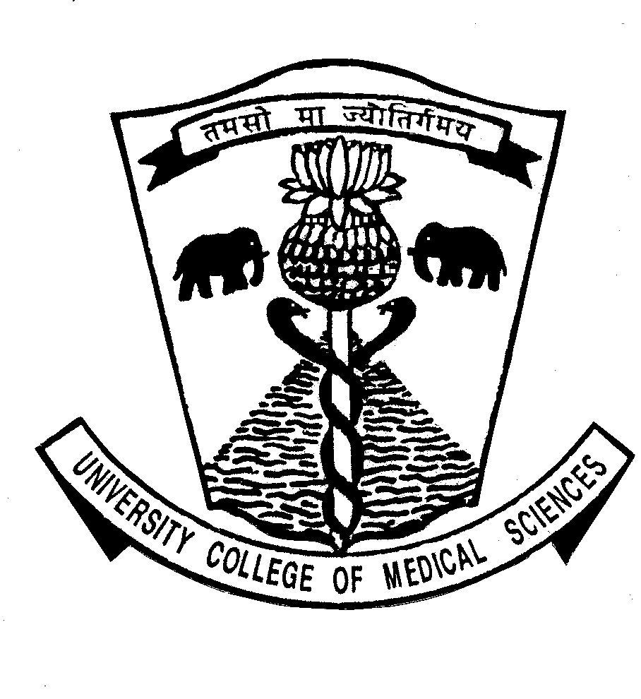 | UNIVERSITY COLLEGE OF MEDICAL SCIENCES & GTB HOSPITAL DILSHAD GARDEN, DELHI-110 095

Draft for advertisement for publication in the Employment Newspaper

Applications are invited for the post of one senior research fellow and one laboratory attendant for ICMR funded research project. Details of educational qualification etc are available on college website www.ucms.ac.in. Application along with complete biodata and testimonials should reach to Prof SB Sharma, Dept of Biochemistry, Room no 223, UCMS & GTB Hospital, Dilshad Garden, Delhi- 110095 on or before 5th June 2015.

Prof SB Sharma
Principal Investigator

